 eMac

Installing or Replacing Memory

Follow the instructions in this sheet carefully. Failure to follow these instructions could damage your equipment and void its warranty.

Note: Written and video instructions covering customer-installable parts are available at http://www.info.apple.com/installparts/.

Tools Required

The only tool required for this procedure is a Phillips screwdriver.

Note: The memory is located behind the user access door shown below.

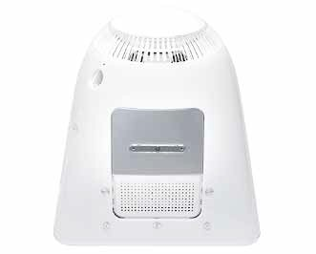

Installing Memory

1. Save open documents and quit all open applications.

2. Turn the computer off by choosing Shut Down from the Special menu (if using Mac OS
9), or choose Shut Down from the Apple menu (if using OS X).

3. Unplug all cables, except the power cord, from the computer. Warning: If the internal modem is connected to a telephone line, disconnect the telephone line from the internal modem port before you open the user access door. This prevent electric shock.

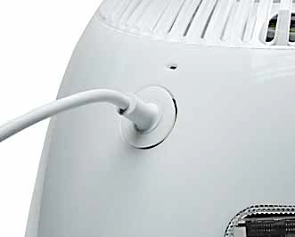

4. Place a soft towel or cloth on the desk or surface.

5. Position the computer so the screen is facing down on the cloth.

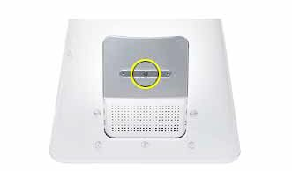6. Use a Phillips screwdriver to remove the screw on the user access door shown below.

7. Touch a metal surface inside the computer. Then unplug the power cord. This helps
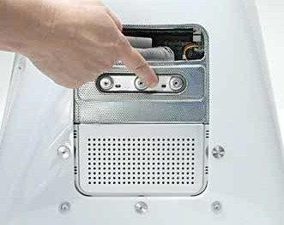
protect the computer from damage caused by electrostatic discharge. Important: To avoid electrostatic discharge, always ground yourself by touching metal before you touch any parts or install components inside the computer. To avoid generating static electricity, do not walk around the room until you have finished installing the memory and closed the computer.

8. Locate the open memory slot.

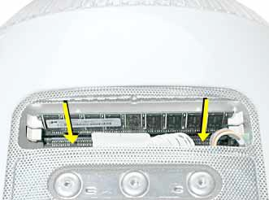

9. Push the ejectors on the memory slot outward and down so they are in the open position. The module is designed to fit into the slot only one way. Be sure to align the notches on the module with the small notches inside the slot.

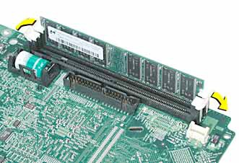

10. Push down on the memory until it snaps into place. The ejectors will automatically close.

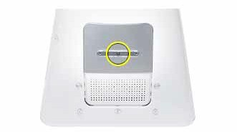12. Gently turn the computer right side up.

13. Reconnect the cables you disconnected from the computer. Important: When connecting the power cord, first plug the cord into your eMac, then plug the other end into an electrical outlet or power strip.

14. Press the Power button on the computer to turn it on. Warning: Never turn on the computer unless all of its internal and external parts are in place and it is closed. Operating the computer when it is open or missing parts can damage your computer or cause injury.

Replacing Memory

1. Save open documents and quit all open applications.

2. Turn the computer off by choosing Shut Down from the Special menu (if using Mac OS
9), or choose Shut Down from the Apple menu (if using OS X).

3. Unplug all cables, except the power cord, from the computer. Warning: If the internal modem is connected to a telephone line, disconnect the telephone line from the internal modem port before you open the user access door. This prevent electric shock.

4. Place a soft towel or cloth on the desk or surface.

5. Position the computer so the screen is facing down on the cloth.

6. Use a Phillips screwdriver to remove the screw on the user access door shown below.

7. Touch a metal surface inside the computer. Then unplug the power cord. This helps
protect the computer from damage caused by electrostatic discharge. Important: To avoid electrostatic discharge, always ground yourself by touching metal before you touch any parts or install components inside the computer. To avoid generating static electricity, do not walk around the room until you have finished installing the memory and closed the computer.

8. Locate the memory module(s). Note: If there are two memory modules, replace one at a time to isolate the faulty memory.

9. Remove the memory module. Push the ejectors on the memory slot outward and down so they are in the open position. Lift the memory from the slot.

10. Insert the replacement memory into the open slot. The memory is designed to fit into the slot only one way. Be sure to align the notches on the module with the small notches inside the slot.

11. Push down on the memory until it snaps into place. The ejectors will automatically close.

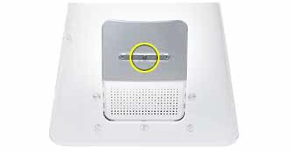12. Replace the screw on the user access panel.

13. Gently turn the computer right side up.

14. Reconnect the cables you disconnected from the computer. Important: When connecting the power cord, first plug the cord into your eMac, then plug the other end into an electrical outlet or power strip.

15. Press the Power button on the computer to turn it on. Warning: Never turn on the computer unless all of its internal and external parts are in place and it is closed. Operating the computer when it is open or missing parts can damage your computer or cause injury.

 Apple Computer, Inc.

© 2002 Apple Computer, Inc. All rights reserved.

This document is protected under U.S. Copyright Law and International Treaties, and no part of this document may be reproduced in any form without written permission from Apple.
Apple is not responsible for typographical, printing, or inadvertent errors. Apple Computer, Inc.
1 Infinite Loop
Cupertino, CA 95014-2084
USA
+ 1 408 996 1010 http://www.apple.com

Apple, the Apple logo, Mac, Macintosh, and the Mac logo are trademarks of Apple Computer, Inc., registered in the U.S. and other countries. Power Mac is a trademark of Apple Computer, Inc.

