Memory
Replacement Instructions

Be sure to follow the instructions in this sheet carefully. Failure to follow these instructions could result in damage to your equipment and may void your warranty.

If you are adding memory rather than replacing it, skip the section “Removing Memory
Cards.”

Note: Written and video instructions covering customer-installable parts are available at http://www.info.apple.com/installparts/.

Warning: Sharp edges can exist inside your computer and on any parts being removed or installed. Use caution to avoid injury.

Tools Required

The only tool required for this procedure is a jeweler’s flat-blade screwdriver.

Memory (RAM)

Your computer comes with two memory slots, one above the other. From the factory, your
PowerBook comes with one memory card installed in the lower slot.

Note: If desired, you can install additional memory in the upper memory slot or replace a memory card in either slot with one of greater memory capacity, up to a maximum of a
512 megabyte (MB) memory card installed in each slot.

Warning: Memory cards come in various specifications. Only install memory cards that are approved for your PowerBook.

Opening the Computer

1. Place your computer on a clean, flat surface.

2. Shut down your computer. Disconnect the power cord and any other cables connected to the computer.

Warning: Always turn off your computer before opening its case to avoid damaging its internal components.

3. Close the computer and turn it over. Slide the battery compartment latch (Figure 1A)
to the right to remove the battery (Figure 1B).

Removing the battery will prevent you from accidentally turning on the computer.

Warning: The internal components of your PowerBook may be hot. If you have been using your PowerBook, wait 30 minutes after shutting down your computer to let the internal components cool down before continuing.

4. Turn over the computer and raise the display so you can access the keyboard.

5. Make sure that the keyboard locking screw is not in the locked position (Figure 2).
Your new PowerBook comes with the keyboard unlocked, so unless you or someone else locked the keyboard, you can skip this step.

6. Release the keyboard by pulling down on the keyboard release tabs located to the left of the F1 and F9 keys (Figure 3), then lift the top portion of the keyboard up and toward the display to release the tabs that hold the bottom of the keyboard in place.

7. Flip over the keyboard and lay it on the palm rests and trackpad (Figure 4).

Perform Electrostatic Discharge

1. Touch the computer’s inside framework (a dull gray conductive composite material) to discharge any static electricity, as shown (Figure 5).

Important: To avoid electrostatic discharge damage, always ground yourself by touching the computer’s framework before you touch any parts or install any components inside the computer. To avoid static electricity building back up in your body, do not walk around the room until you have completed your installation and closed the computer.

Removing Memory Cards

Warning: When removing or installing a memory card, do not touch its gold connectors. Handle the card only by the edges.

1. To remove a memory card, locate the brackets that secure the card on both sides.
Carefully spread the brackets apart until the card releases on each side (Figure 6). The card can then be pulled up and out.

Note: If there is a memory card in the upper memory slot (Figure 6B), it must be removed before removing a card in the lower slot (Figure 6A).

Installing Memory Cards

Warning: When removing or installing a memory card, do not touch its gold connectors. Handle the card only by the edges.

1. To install a memory card, hold the card at a 30-degree angle (Figure 7A). Line up the notch in the card with the small tab in the memory slot. Then push the card into the slot (Figure 7).

Note: You may feel some resistance. If you are having trouble inserting the card, try pushing one side at a time.

2. Gently push the card down until the brackets snap onto both sides of the memory card to lock it into place (Figure 8).

Closing the Computer

1. Verify that the keyboard connector cable is securely attached to the logic board
(Figure 9).

2. Flip the keyboard back on top of the opening and insert the tabs at the bottom of the keyboard into the openings in the case (Figure 10).

3. Pull down on the keyboard release tabs located to the left of the F1 and F9 keys
(Figure 3) and then press down on the top of the keyboard.

4. Release the tabs to secure the keyboard in place.

5. Turn over the PowerBook and replace the battery (Figure 11).

6. Reconnect the power cord and any other cables that were connected and restart your computer.

Warning: Never turn on your computer unless all of its internal, external, and case parts are securely installed. Operating the computer when its case is open or missing parts can damage your computer or cause injury.

 Apple Computer, Inc.

© 2001 Apple Computer, Inc. All rights reserved.

Under the copyright laws, this document may not be copied, in whole or in part, without the written consent of Apple.

The Apple logo is a trademark of Apple Computer, Inc., registered in the U.S. and other countries. Use of the “keyboard” Apple logo (Option-Shift-K) for commercial purposes without the prior written consent of Apple may constitute trademark infringement and unfair competition in violation of federal and state laws.

Every effort has been made to ensure that the information in this document is accurate. Apple is not responsible for printing or clerical errors.

Apple Computer, Inc.
1 Infinite Loop
Cupertino, CA 95014-2084
USA
+ 1 408 996 1010 http://www.apple.com

Apple, the Apple logo, and PowerBook are trademarks of Apple Computer, Inc., registered in the U.S. and other countries.

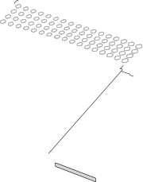A

B

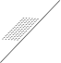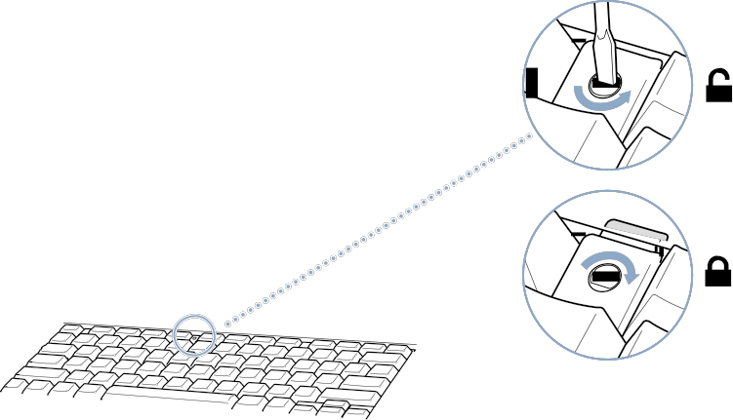Figure 2

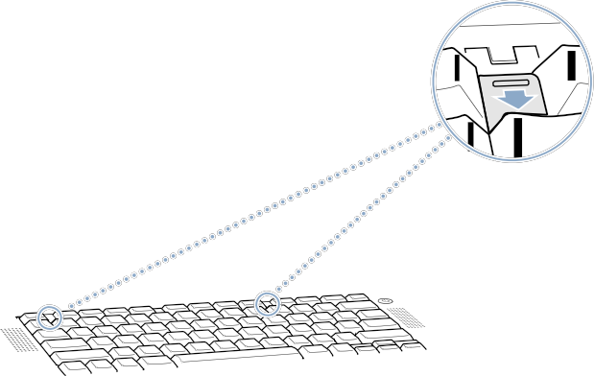Figure 3

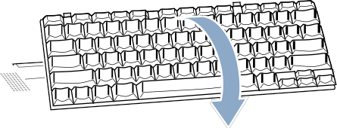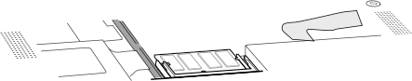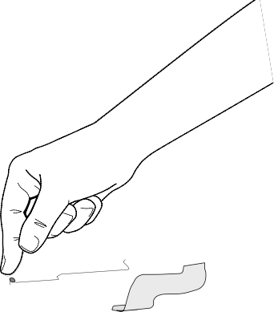Figure 5

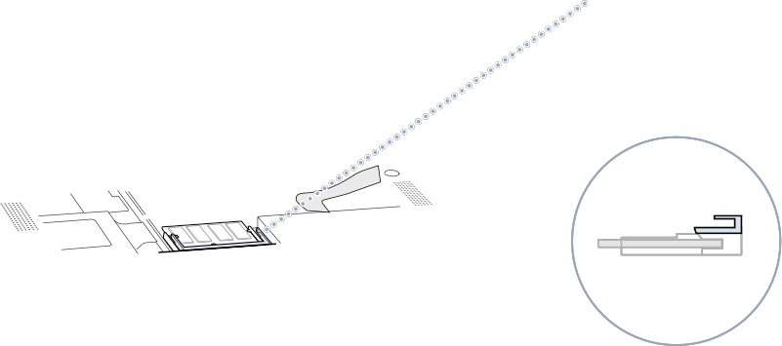Figure 6

A B

A

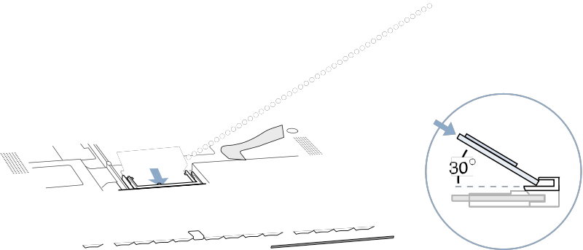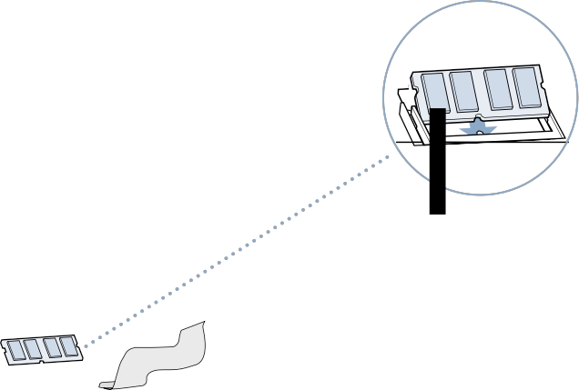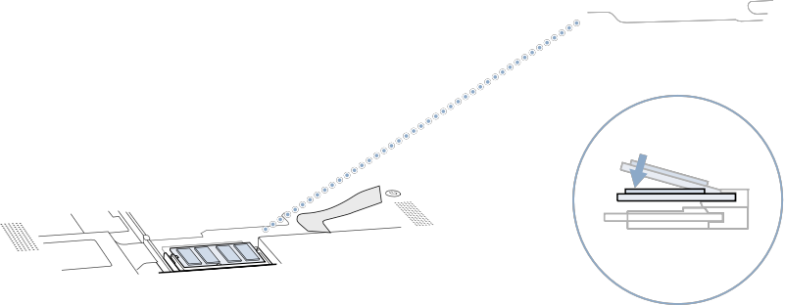Figure 8

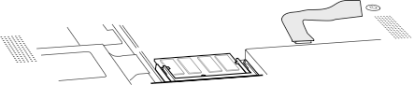Figure 9

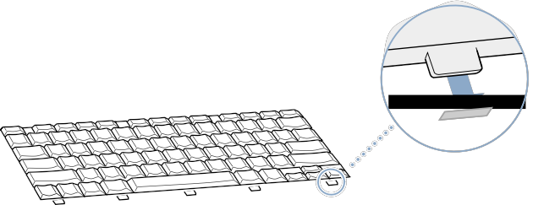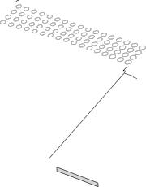Figure 11

