Hard Drive
Replacement Instructions

Follow the instructions in this sheet carefully. Failure to follow these instructions could damage your equipment and void its warranty.

Note: Written and video instructions covering customer-installable parts are available at http://www.info.apple.com/installparts/.

Warning: Sharp edges can exist inside your computer and on any parts being removed or installed. Use caution to avoid injury. Keep small parts away from children.

Tools Required

• Soft towel or cloth, larger than the PowerBook
• Torx T8 screwdriver (provided with hard drive)

Backing Up Your Data

Warning: Before replacing your hard drive, make sure you back up all data on the drive.

Opening the Computer

Warning: Always shut down your computer before opening it to avoid damaging its internal components or causing injury. After you shut down the computer, the internal components can be very hot. Let the computer cool down before continuing.

To access the hard drive, you must first remove the battery and bottom case.

1. Place your computer on a clean, flat surface.

2. Shut down your computer and wait thirty minutes before continuing.

3. Disconnect the power cord and any other cables connected to the computer.

4. Place a towel or soft cloth on a table in front of you. (Figure 1A)

The towel or cloth will protect the keyboard and display area of the PowerBook when you flip it over to remove the battery and bottom case. Make sure it covers an area large enough for your PowerBook and that it hangs over the edge of the table.

5. With the display open at an angle greater than 90 degrees, carefully flip the PowerBook over and lay it flat, fully on the table. Make sure the display hangs over the edge of the table and rests lightly on your lap. (Figure 1B)

Important: Do not open the display farther than the angle shown.

Figure 1

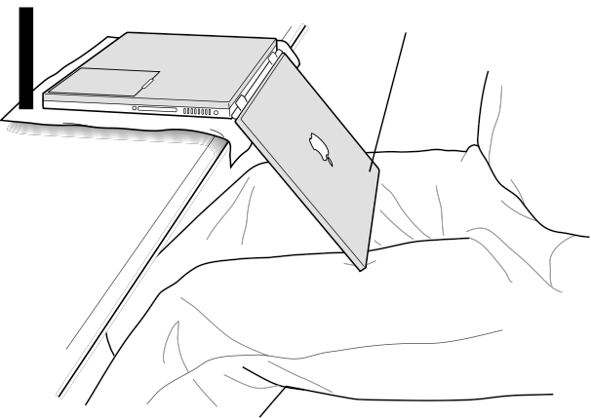A
B

6. Remove the battery by sliding the battery latch to the left. Make sure to return the latch fully to the right. (Figure 2)

Removing the battery will prevent you from accidentally turning on the computer.

Warning: Removing the battery before shutting down your computer may result in data loss.

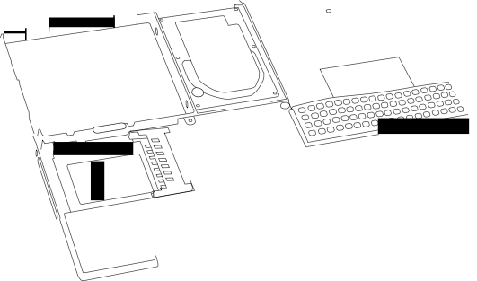Figure 2

7. Using a Torx T8 screwdriver, remove the eight bottom case screws in the order shown in the illustration. (Figure 3)

Important: To avoid damaging the case, be careful that the screwdriver tip does not slip out of the screw head during removal.

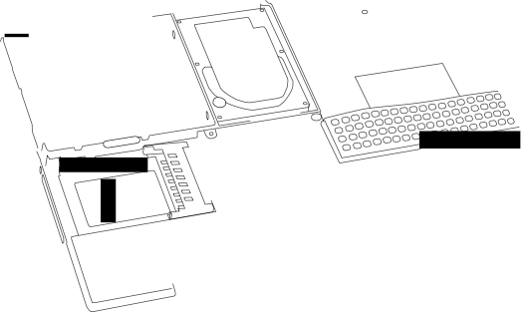Figure 3

1
4
3
2
5
8
7
6

Note: The following three steps explain how to remove the bottom case by disengaging it at the left and right sides and then carefully pivoting it forward.

Important: During this procedure, do not push on the rubber feet of the bottom case.

8. Place your hands on the bottom case as shown (Figure 4) and push away from you until the left side releases.

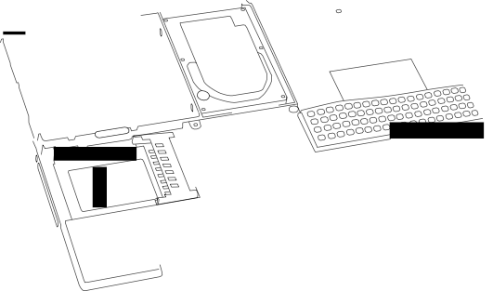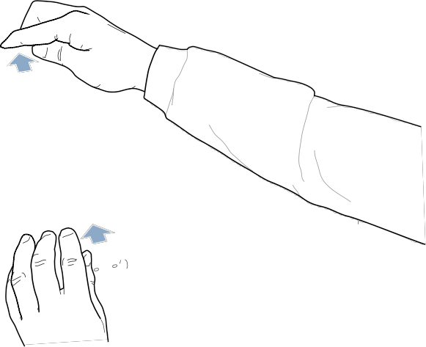Figure 4

9. Place your hands on the bottom case as shown (Figure 5) and push away from you until the right side releases.

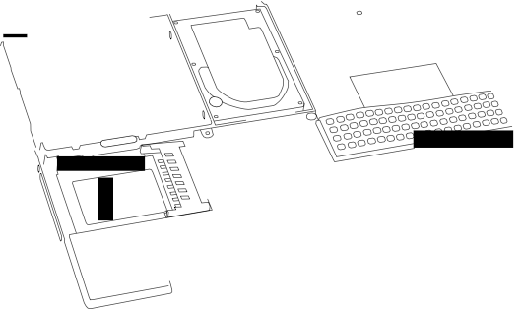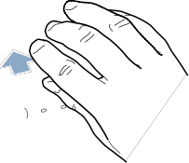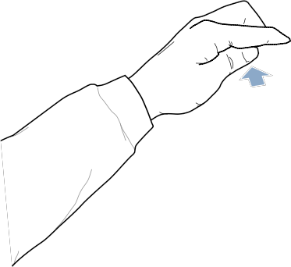Figure 5

10. When both sides have released, lift up on the edge of the bottom case that is closest to you; carefully and evenly pivot it over the front edge of the computer until it releases. (Figure 6)

Important: Do not twist the bottom case from side to side. Slide the case forward completely before lifting it up. If you feel any resistance when lifting the bottom case, double-check to make sure the case is slid all the way forward and releases from the front edge.

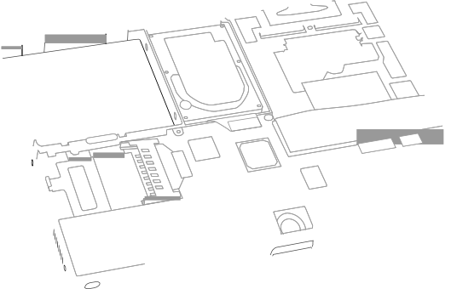Figure 6

11. Touch the computer’s inside framework (a dull gray conductive composite material) to discharge any static electricity, as shown. (Figure 7)

Important: To avoid electrostatic discharge damage, always ground yourself by touching the computer’s framework before you touch any parts or install any components inside the computer. To avoid static electricity building back up in your body, do not walk around the room until you have completed your installation and closed the computer.

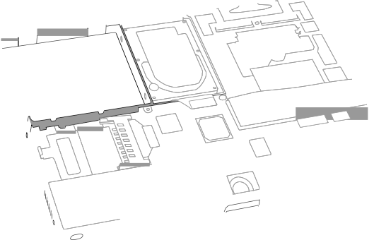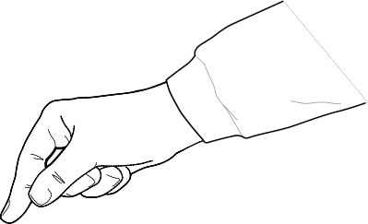Figure 7

Removing the Installed Hard Drive

1. With your fingers, carefully pry up the hard drive cable connector (Figure 8) at its sides to disconnect it from the logic board. You may need to pry one side, then the other, in a rocking motion.

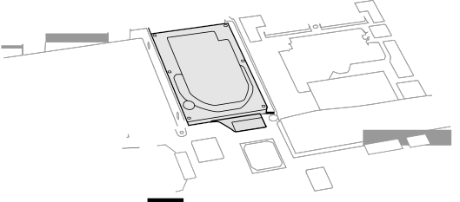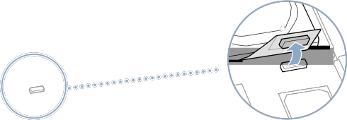Figure 8

2. With a Torx T8 screwdriver, remove the two screws (Figure 9) that secure the hard drive to the mounting bracket and then gently remove the hard drive.

Important: Do not pull on the connector cable or use the cable as a handle.

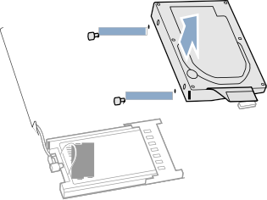Figure 9

Note: There are four rubber stoppers on the hard drive that fit over screws (two on each side). Remove any that may have fallen off or that remain in the holes in the mounting bracket inside the computer.

3. Replace the screws and rubber stoppers back onto the removed hard drive.

Installing the Replacement Hard Drive

Warning: To avoid potential injury, avoid touching or brushing against the thin strip of metal that extends up from the hard drive mounting bracket (Figure 10A).

Important: Avoid touching the optical drive as you perform this procedure.

1. With a Torx T8 screwdriver, remove the screw from the top of the hard drive mounting bracket. (Figure 10B)

2. Carefully lift the mounting bracket up (Figure 10C) and gently bend it around the first battery bay tab (Figure 10D). The tab holds the bracket out of the way.

Warning: Lift the bracket just high enough to clear the battery bay tab. If you lift the bracket higher than the tab you risk damaging the bracket, and such damage is not covered by the limited warranty on your computer.

Figure 10

B
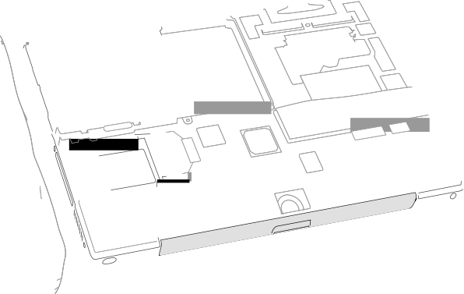D C

A

3. Verify that the replacement hard drive has four screws (Figure 11A), two on each side, with four rubber stoppers (Figure 11B) attached.

Important: If any screws or stoppers have come off, screw the screws back onto the hard drive and then slide the rubber stoppers over them until they are against the drive. Make sure that the Mylar sheath (Figure 11C) wraps around the bottom and left and right sides of the drive, and that the rubber stoppers protrude through the holes in the sheath along the sides.

Figure 11

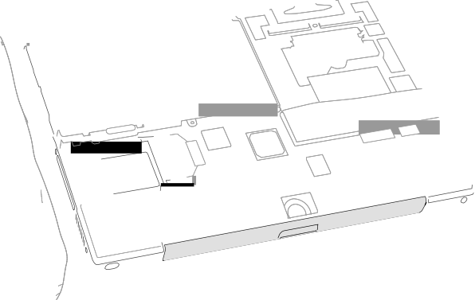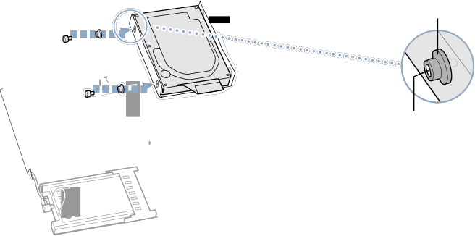C B

A

4. Insert the right side of the drive first, until the rubber stoppers fit securely into the holes in the bracket, and then insert the left side of the drive. (Figure 12)

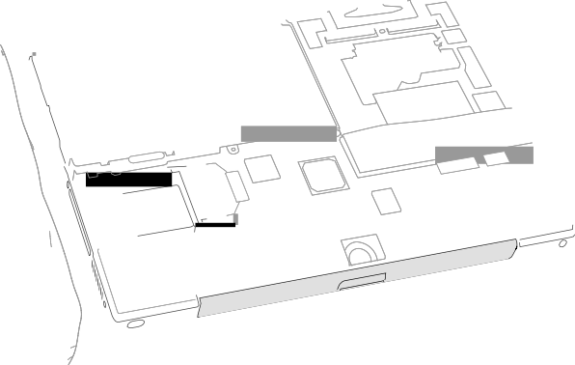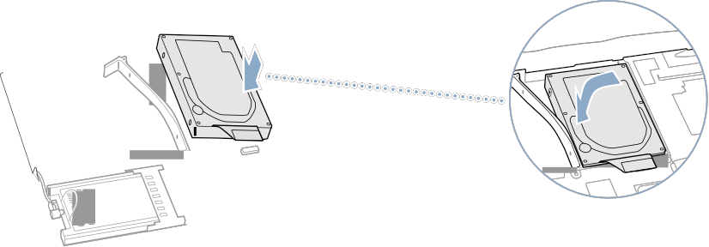Figure 12

5. Lift the mounting bracket (Figure 13A) over the battery bay tab and lower it to its original position. Line up the rubber stoppers on the hard drive until they fully seat into the holes in the bracket.

Note: To help with alignment, the Torx T8 screwdriver can be inserted into the screws on the hard drive through the holes in the mounting bracket.

Important: Verify that the bottom of the mounting bracket clears and seats behind a thin metal ridge located along the bottom of the battery compartment. (Figure 13B)
6. Replace the screw (Figure 13C) in the top of the mounting bracket, being careful not to overtighten it.

Figure 13

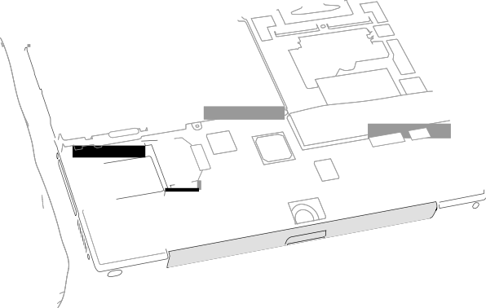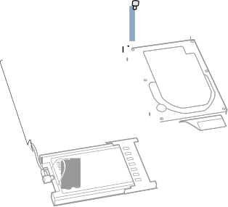C A

B

7. Connect the hard drive cable connector (Figure 14) to the logic board.

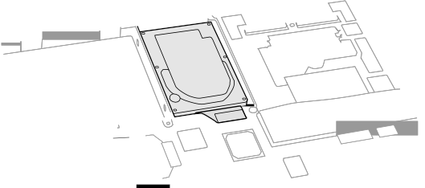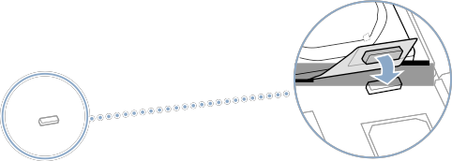Figure 14

Closing the Computer

1. To replace the bottom case, place it over the bottom of the computer in the same orientation as the original bottom case.

2. Align the notches on the right and left sides of the case (some of these can be viewed through the battery opening). Then press down and toward you slightly to secure the case.

Important: Make sure that the seams between the bottom case and the frame are closed. Verify that the case lies flat and fits properly around the battery latch and that the alignment tab that protrudes on the underside of the bottom case, shown in the illustration (Figure 15A), is seated properly.

Note: To help with alignment, apply pressure to the bottom case at the back of the battery compartment opening, near the latch, and on the front and back outside edges of the case.

3. Check that the eight screw holes on the case align with the holes on the computer.

4. Replace the eight screws in the order shown in the illustration (Figure 15). Do not overtighten the screws or damage could result.

Note: The screws must go in straight and easily; if they do not, readjust the bottom case for proper alignment.

Important: To avoid damaging the case, be careful that the screwdriver tip does not slip out of the screw head during tightening.

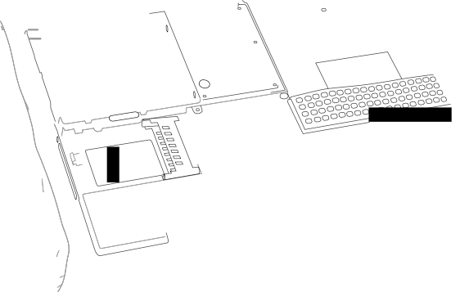Figure 15

8
5
A 6
7
2 4
1
3

5. Replace the battery. (Figure 16)

Important: Make sure that the battery locks securely into place and that the battery latch is slid all the way into the locked position.

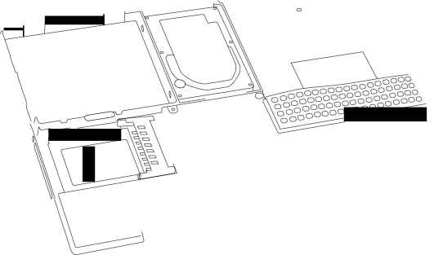Figure 16

6. Turn the computer over so that the optical drive slot faces you. Verify that the bottom case is flush with the front edge of the slot. If the case is slightly bowed and there is a gap near the center of the slot, carefully pull the bottom edge of the slot until it clicks into place and becomes flush with the bottom case. (Figure 17)

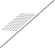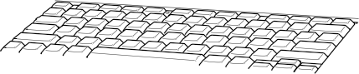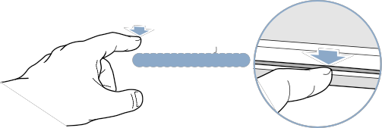Figure 17

7. Reconnect the power cord and any other cables that were connected, and restart your computer.

Warning: Never turn on your computer unless all of its internal and external parts are in place and it is closed. Operating the computer when it is open or missing parts can damage your computer or cause injury.

8. Restore the data from your backup to the new drive.

9. Check the operation of the optical drive. If the hard drive is installed incorrectly, the optical drive mechanism might not spin correctly and will result in mechanical noise when playing a disc.

 Apple Computer, Inc.

© 2001 Apple Computer, Inc. All rights reserved.

Under the copyright laws, this document may not be copied, in whole or in part, without the written consent of Apple.

The Apple logo is a trademark of Apple Computer, Inc., registered in the U.S. and other countries. Use of the “keyboard” Apple logo (Option-Shift-K) for commercial purposes without the prior written consent of Apple may constitute trademark infringement and unfair competition in violation of federal and state laws.

Every effort has been made to ensure that the information in this document is accurate. Apple is not responsible for printing or clerical errors.

Apple Computer, Inc.
1 Infinite Loop
Cupertino, CA 95014-2084
USA
+ 1 408 996 1010 http://www.apple.com

Apple, the Apple logo, and PowerBook are trademarks of Apple Computer, Inc., registered in the U.S. and other countries.

